Sprint #02 Planning

**Sprint**: Sprint 02

**Date**: 18/05/2020

**Scrum Master**: Yan Ni Zhao (s3782495)

**Development team**: Nathan Kaspers (s3668382), Carlin McNamara (s3784664), Varun Pereira (s3842244), Xiaoyu Zhao (s3732764), Ziqiang Lin (s3792327), Nipun Herath Mudiyanselage (s3839956)

## Sprint Goal

**Sprint Goal:** At the end of Sprint #2, our goal is to successfully develop the features ‘review’ and ‘critic request’ whilst also completing spill over fuser story feature from Sprint #1.

**Sprint Capacity**: 110 hours

**Special Circumstances**: Null

## Sprint Goal & User Stories

|  |  |  |  |
| --- | --- | --- | --- |
| **ID** | **User Story** | **Priority** | **Effort** |
| 3 | As a Production Company, I want to register an account, so that I can promote my movie that I have just released. | High | 3 |
| 4 | As a Production Company, I want to register an account, so that I can see how big of a success my movie will be. | High | 3 |
| 24 | As a logged in Movie producer, I want to submit a request to add a movie into the site, so that users can search up the movie. | High | 5 |
| 25 | As a logged in site Admin, I want to accept the movie request made by the Movie producer, so that I can add more movie information to the site's database. | High | 3 |
| 26 | As a logged in site Admin, I want to decline the movie request made by the Movie producer, so that the site's movie information database will not include the movie that was requested. | High | 3 |
| 33 | As a logged in Admin, I want to accept the review request a critic user has submitted, so that users of the site can see the review of this movie. | High | 5 |
| 34 | As a logged in Admin, I want to deny a movie review request send by the critic, so that this request will not be included into the movie's reviews. | High | 3 |
| 35 | As a logged in site Admin, I want to review and decline critic requests that have been submitted, so that the critic won't be able to sent reviews. | High | 3 |
| 36 | As a logged in site Admin, I want to review and accept critic requests that have been submitted, so that the site will have Critic users to create reviews. | High | 5 |
| 27 | As a logged in site Admin, I want to add the movie information I have accepted from the Movie producer, so that users can find and view this movie. | Medium | 8 |
| 29 | As a logged in site Admin, I want to remove the movie information based on reports by Movie producers of the site, so that movies will not appear in user's search results. | Medium | 5 |
| 32 | As a logged in Movie producer, I want to send information about the newly accepted movie to the site Admin, so that the Admin can add a new movie with correct information onto the site. | Medium | 5 |
| 7 | As a Movie Critic, I want to register an account, so I can submit reviews for movies I have seen. | Low | 3 |
| 8 | As a Movie Critic, I want to register an account, so I can build my platform of followers. | Low | 3 |
| 12 | As a registered critic, I want to login into the web, so that I can use the web to know more information about different movies. | Low | 5 |
| 16 | As a logged in user, I want to write a review so that others can form opinions on the movie. | Low | 5 |
| 17 | As a logged in user, I want to leave a constructive review so that producers can recieve feedback about their movies. | Low | 5 |
| 18 | As a guest user, I want to search reviews so that i can get the best recommendations | low | 8 |
| 19 | As a critic, I want to edit a review so that I can update my opinion. | low | 8 |
| 21 | As a producer, I want to leave a review so that I can share my tips with other producers. | low | 5 |
| 22 | As a critic, I want to delete a review so that I can withdraw my viewpoint. | low | 3 |
| 23 | As a critic, I want to leave a rating so that viewers will quickly understand my opinion. | low | 5 |
| 28 | As a logged in site Admin, I want to edit the movie information based on reports by users of the site, so that the movie information is corrected. | Low | 8 |
| 30 | As a logged in site member, I want to report a movie's description for spelling/grammar mistakes, so that the admin will be notified to fix this mistake. | Low | 5 |
| 31 | As a logged in Movie producer, I want to report to remove a movie that exists on the site, so that incorrect movies will not appear in the user's search results. | Low | 3 |

Majority of the User stories placed on ‘3’ for estimation of effort involve accepting, declining, and deleting reviewed data. The reason for this is simple boolean to informative data, to be deleted if it is rejected information. Outliers for effort ‘3’ are flow over from sprint #1 for the feature ‘registration’.

User stories placed on ‘5’ or ‘8’ estimation of effort involve saving or editing data from pre-determined forms. This is more complicated as each form has slight variations from each other. User stories under ‘8’ also include a search mechanic, therefore requiring more effort.

## Summary

### Github:

<https://github.com/sef-2021-s1/team-project-m-17>

### Clickup:

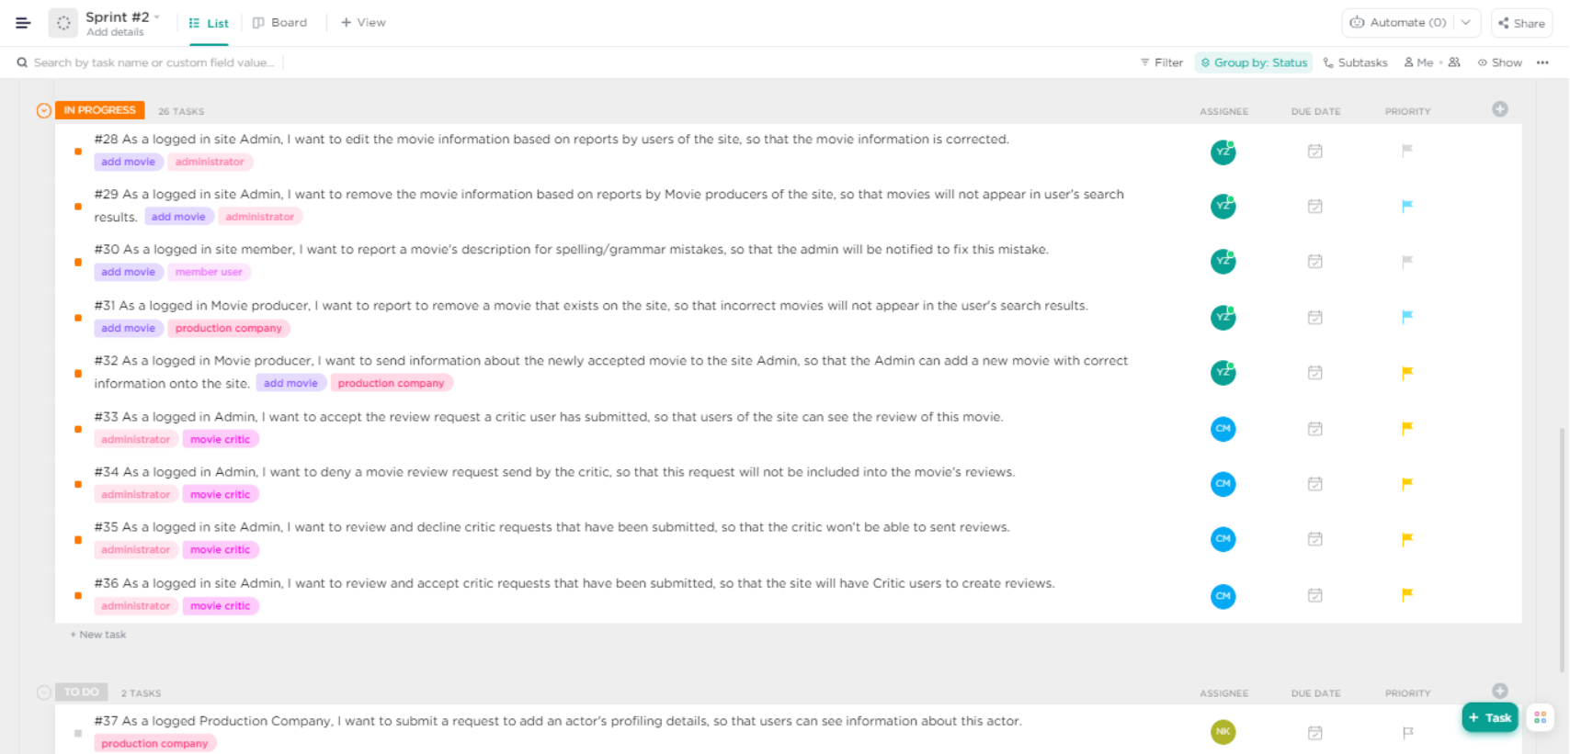

### Tasks:

|  |  |
| --- | --- |
| **Task** | **Team Member** |
| * Scrum Sprint   + Sprint Planning   + Sprint Backlog   + Sprint Review   + Sprint Retrospective   + Clickup   + Dod | YanNi  Varun, YanNi  Xiaoyu  Xiaoyu  YanNi  YanNi |
| * Coding & Implementation of features | Carlin |
| * Video Demonstration of working in process system | Carlin |
| * Acceptance Diagram | Nathan, Nipun, Ziqiang |
| * Unit Testing | Ziqiang |
| * Contribution Form | YanNi, Nathan, Xiaoyu, Nathan, Varun, Ziqiang & Nipun |

Our team runs our discussions through Messenger. Since the merge of new members, not everyone is available to attend 5:30pm meetings in Mahak Khera’s tutorials.

Here are some snapshots of our conversations.

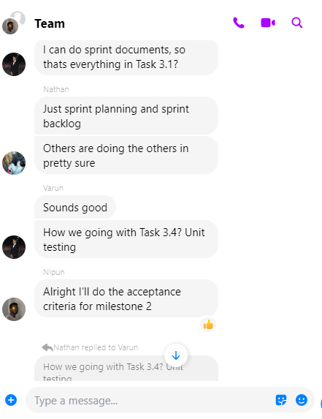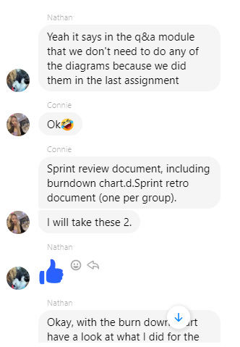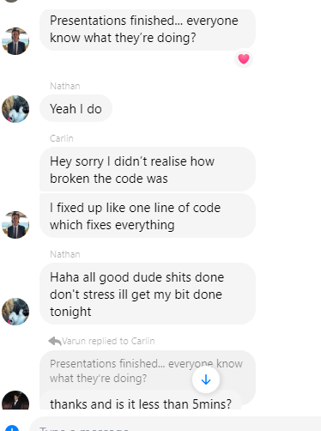

Throughout the meetings, we had difficulties figuring out how to allocate coding work to each of the members. Most of our members are not confident in java and it is difficult to start working on other languages we are familiar with that also incorporate java, without starting from scratch. We ended up deciding to let Carlin handle the coding whereas the rest of the team shared the documentation part of the project.